COOP 199

**INSTRUCTOR:**

Lisa Bennett, STEM Navigator/ Cooperative Education Coordinator

Phone: (360) 416-7693; FAX: (360) 416-7676; Appointments: (360) 416-7693

Email: Lisa.Bennett@skagit.edu Website: <http://www.skagit.edu/coop>

(Click [*here*](http://www.skagit.edu/directory.asp_Q_pagenumber_E_53) to go to the Co-op Ed web page)

Office: located in the Counseling & Career Services Office, in Lewis Hall Building

BD04947_Drop-In Office Hours:

Monday 9:00am - 11:00am

Tuesday 9:00am - 11:00am

Wednesday 9:00am - 11:00am

Thursday 9:00am - 11:00am

**Friday BY APPOINTMENT ONLY**

***Students may schedule appointments at other times by email or phone***

**THE COOPERATIVE EDUCATION PROGRAM (CO-OP ED):**

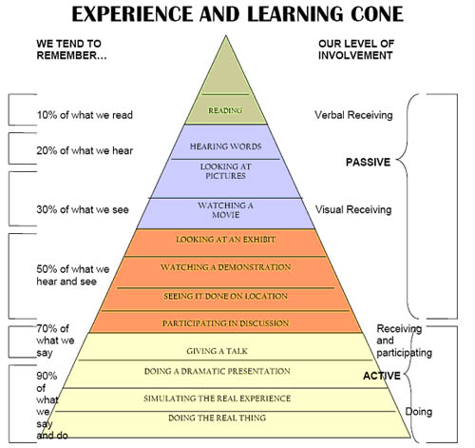

Cooperative Education at [Skagit Valley College](http://www.skagit.edu/) is a work-based learning program that helps students to bridge the gap between classroom theory and practical work situations. ***Students are responsible for finding their own work placements***, which may be paid or unpaid positions related to their field of study.

Cooperative Education combines college classes with relevant work-based learning experience to enhance the learning process and enable students to explore possible employment choices and improved knowledge of what skill or preparation is necessary for a successful career.

The student, faculty sponsor, employer and Co-op Ed Coordinator work closely together to ensure a successful learning experience. The only pre-requisite to participate in Cooperative Education 199 is faculty permission. The faculty can also tell you how many credits you need for your program.

**STUDENT RIGHTS AND RESPONSIBILITIES**

Skagit Valley College provides a drug-free environment and does not discriminate on the basis of race, color, national origin, sex, disability, sexual orientation, or age in its programs and employment.

Cooperative Education students, as employees, are expected to follow the host employer’s rules and regulations, unless a specific exception has been agreed upon. Students are expected to provide adequate notice if unable to attend work due to illness, or if the student accepts a position with another employer.

#### COOPERATIVE EDUCATION HOURS/CREDIT OPTIONS

College credit for work-based learning is generally considered to be about 50 hours of work for each credit earned toward your degree or certificate. In most cases, the time spent in the weekly discussion boards makes up for the difference between the two options. Those students participating in the weekly online discussion board will need to work fewer hours at the job site to complete their total requirements. Most students have two choices for fulfilling Co-op Ed requirements: 30 hours of work per credit WITH participation in the weekly Online Discussion Board or 50 hours of work per credit WITHOUT Seminar. (Mid-Term Paper instead)

**Note: MIT-199 Students and CIS-199 students are required to select the 50 hours/credit option.**

CIS-199 and MIT-199 students may still opt between participating in the online weekly discussion board or the mid-term paper but still have the 50 hours/credit requirement.

The two options are explained in detail below:

**30 Hours\*/Credit Option:** In this option, college credit is awarded at the rate of one credit for every 30 hours of work during the quarter. For example, a student taking a three-credit Coop Ed-199 class must work 90 hours over the **8-week Spring Quarter**. That averages to 11.25 hours per week. Students choosing this option must also participate in a weekly online discussion facilitated by the

BD06933_Co-op Ed Coordinator. The Co-op Ed Online Discussion Board uses Canvas. The Discussion Forum begins on **Monday July 8th** and runs for eight weeks. Each Monday, the Co-op Ed Coordinator will post a general, workplace-related discussion topic. Students are expected to respond to the weekly topic and are expected to interact with other students participating in the discussion. **All students** will submit an updated resume that includes your coop work experience and turn in all required evaluations and timesheets at the end of the quarter. (Please check [**Assignment Due Dates**](#_ASSIGNMENTS__) in this syllabus for more details).

**50 Hours\*/Credit Option:** In this option, credit is awarded at the rate of one credit for every 50 hours of work over the quarter. For example, if you take a three-credit -199 class, you will be required to log 150 hours over the **8-week Spring Quarter**. That is almost 19 hours per week on the job site. Students choosing this option are not required to participate in the online discussion, but may do so for extra credit. Instead, they will submit a mid-term analytical paper about their work experience halfway through the quarter. (See [**Midterm Paper**](#_Mid-Term_Paper:_Due) under[**Paperwork**](#_FORMS_AND_PAPERWORK) for details on this assignment). **All students** will submit an updated resume that includes your coop work experience and turn in all required evaluations and timesheets at the end of the quarter.

(Please check [**Assignment Due Dates**](#_ASSIGNMENTS__)in this syllabus for more details).

If you have already completed a previous quarter of Co-op Ed, check with the Co-op Ed Coordinator regarding your assignments and subsequent requirements.

**All students should complete the Co-op Ed orientation ON-LINE QUIZ prior to beginning their work based learning experience.**

****

**To complete the** [**On-line Orientation**](file:///C:\Users\brock.veltri\Downloads\On-line%20Orientation) **Quiz read the following orientation page first, find it on the SVC Co-op Ed Web page** [**http://www.skagit.edu/co-op**](http://www.skagit.edu/co-op)**. You’ll be asked to read the information, then take the quiz found on the CANVAS page. This quiz is worth 10% of your overall grade.**

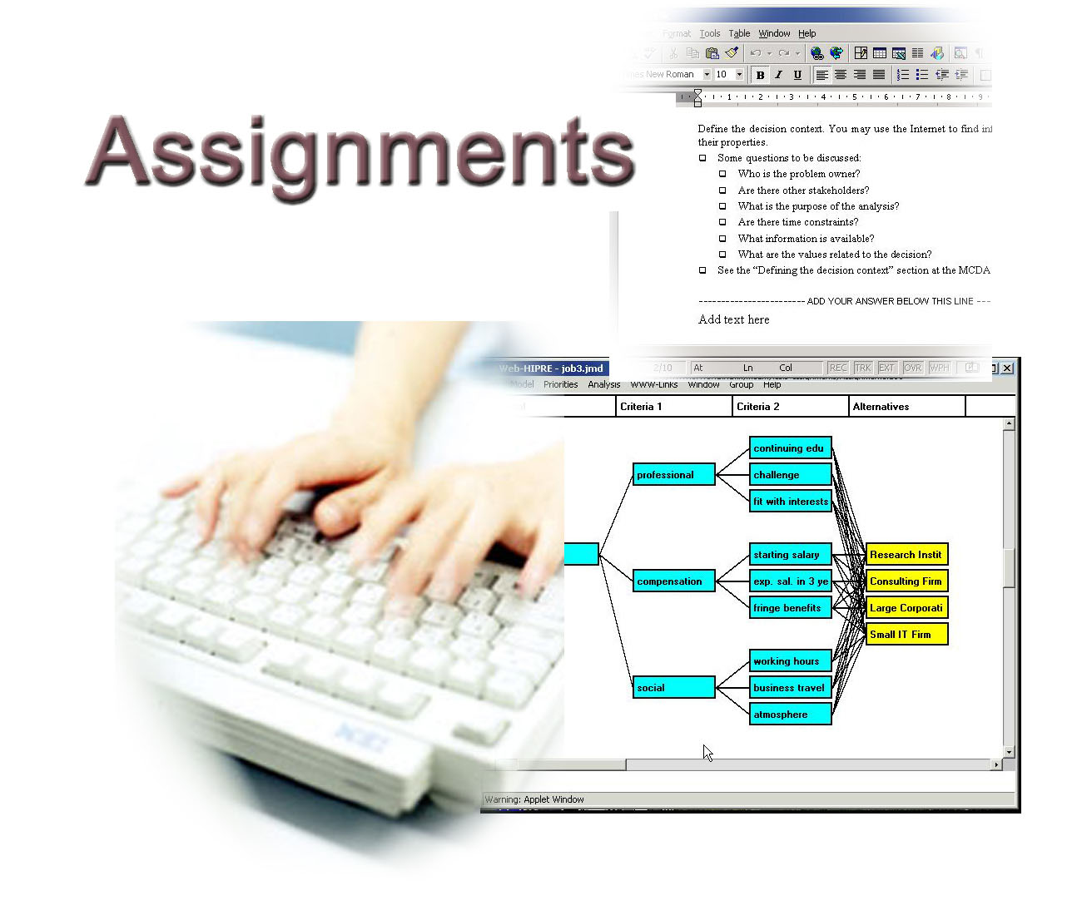

#### There are nine assignments to complete and submit to earn credit for Cooperative Education. The first four must be turned in prior to beginning work at the job site and all are due in the second week of the quarter. Assignments can be emailed, hand delivered, FAXed, sent via regular mail, or submitted on CANVAS where allowed. There are advantages and disadvantages for each method so students should choose a delivery method that works best for them. If you cannot meet that deadline, ensure you are keeping the Co-op Ed Coordinator informed of your plans and progress.

#### 

#### ASSIGNMENTS DUE DATES

On-line Orientation Quiz: July 5, Friday

Learning Contract: July 5, Friday

Supervisor Contact Information Survey July 5, Friday

Learning Objectives: July 5, Friday

Online Weekly Discussion: (30 hr/credit students only) July 8th, Mon - Fri Aug 23rd (weekly)

Midterm Paper: (for 50 hr/credit students only) July 26, Friday

Final Resume: August 23, Friday

Supervisor Evaluation: August 23, Friday

Student Self Evaluation: August 23, Friday

Timesheets: August 23, Friday

#### GRADING

Co-op Ed is a graded class. Final overall grades are earned based on the following scale:

BD06982_ A = 95-100 points C= 73-76 points

A-= 90-94 points C-= 70-72 points

B+ = 87-89 points D+= 67-69 points

B= 83-86 points D= 63-66 points

B-= 80-82 points D-= 60-62 points

C+= 77-79 points E= 59 points and below

Points are earned for completing the assignments as outlined on the next page.

The small print that follows each assignment lists common ways students lose points on the assignment:

#### BD19827_GRADING – 100 points possible

**Orientation Quiz**: **10 points**

If you cannot complete the online orientation, contact the Co-op Ed Coordinator to

schedule a 1-on-1 orientation session. ECE students check with your department for

group orientations

**Learning Contract**: **10 points**

Points are deducted for missing information, missing signatures, or unexcused lateness

**Supervisor Contact Info Survey**: **7 points**

All supervisor contact info must be complete and correct to get the 7 points.

**Learning Objectives**: **15 points**

Points are deducted for missing signatures, and incomplete Learning Objectives or lateness

**Reflective Writing Component**: **15 points**

*(Online Seminar for 30-hour option or Mid-term Analytical Paper for students with the 50-hour option)*

2 Points for fully completing each item listed on the analytical paper grading rubric (see midterm and final papers in syllabus)

~1.8 Points each week for participating in the weekly online discussion board via Canvas.

Points are deducted for unexcused late papers or not given for lack of discussion board participation

**Student Self-Evaluation**: **10 points**

Points are deducted for lack of content or incomplete or unclear answers

Points are deducted for late papers.

**Supervisor Evaluation or Web Design Evaluation**: **15 points**

Points are deducted for tardiness, missing information or missing signatures.

**Final Resume**: **15 points**

2 Points for fully completing each item listed in the resume grading rubric.

Points are deducted for late resumes.

**Timesheets**: **3 points**

3 Points for submitting timesheet, signed by student AND supervisor, submitted on time with all required hours shown

**Total points possible 100 points**

BS00622_Please note: Strong emphasis is placed on timely submission of all assignments - including online seminar postings. Late assignments are subject to points deductions. If you have any questions regarding due dates or believe your circumstances warrant an extension or other consideration, please contact the Co-op Ed Coordinator immediately. As with any job or internship, communication is vital to success! Keep a copy of this syllabus handy so you can refer to it often for detailed instructions or key due dates during the quarter.

#### FORMS AND PAPERWORK

In addition to the Mid-Term Analytical Paper (for all 50-hour option and MIT & CIS students) and the Final Resume, here is more information about the various forms that need to be submitted as assignments to receive credit for the 199 course.

**Assignments on designated forms:**

**Learning Contract.** The contract identifies the student and the host employer. The contract is a statement of agreement between you and the employer/host organization for you to do your Co-op Ed work experience at a specific agency/business. This is an easy assignment: just fill in the blanks. Be sure to list the Job Title AND a description of your duties. Don’t assume that I know what a sous chef does. (I think I DO know). Indicate which credit option (50 or 30 hours per credit) you’ve chosen and how many work hours you’ll need to earn the credits you’re seeking. The contract requires four signatures. **You are responsible for obtaining the first three signatures prior to turning it in to me. I’ll sign the Co-op Ed Coordinator line when I get it. 10-points max**.

**Supervisor Contact Information Survey.** This is an on-line survey you will need to fill out in conjunction with your Learning Contract to ensure that we have the correct contact information for your supervisor. This is required as I make site visits early on in the quarter, based on the information you provide.

**More assignments on designated forms:**

**Learning Objectives.** Other than finding the actual job placement, this can be the hardest part of the whole course. Unlike every other class you attended in college, you are now responsible for drafting your own learning objectives. The Co-op Ed Coordinator outlines how to create quality objectives on the orientation web page. Everyone must develop at least two learning objectives plus a number of additional objectives equal to the number of credits the student is taking for their Co-op-199 class. For example, a three-credit 199 class will require 5 learning objectives. (2 + 3) Writing S.M.A.R.T., goal-oriented objectives is a key part of the Co-op Ed experience and helps focus student learning during the work experience. Objectives must be related to your educational and/or career goals. **The Learning Objectives form must be signed by all relevant stakeholders just like the Learning Contract.** I can make myself available to help you create your objectives and provide feedback if you need it. 15 points max. ***Note: Your Learning Objectives can become powerful résumé bullets very easily so it is to your special advantage to take some time to produce and achieve good quality goals.***

**Student Self Evaluation.** Just answer the nine questions on this form. If there is not enough space for you to write everything you want to say, attach another paper. Answer the questions completely and clearly. Question #5 is of particular importance, so be certain to identify the skills you’ve gained or found necessary to have be successful in your chosen field of employment. These are skills you’ll want to emphasize on future résumés. 10 Points possible.

**Supervisor Evaluation. NEW ON-LINE FORM** The student is responsible for ensuring the employer completes this form on-line. Submitting it on-line automatically send it to the Co-op Ed Coordinator. This completed form is worth 15% of your grade, so it important to make certain your work site supervisor completes it. Be sure your supervisor knows up front that he/she will be evaluating your performance in the areas of attitude, dependability, quality of work, skills, and achievement of learning objectives among others. 15 Points for this assignment.

**BS02067_*Note: MIT students will use the Web-Design Evaluation form***

***instead of the Supervisor Evaluation***.

**Web-Design Evaluation (for MIT-199 students).** MIT students creating

or redesigning a website for a client will need to turn in this evaluation of the

website s/he has created or redesigned instead of the Supervisor Eval.

The evaluator needs to be identified at the outset of the project. This

could be your client; supervisor; MIT faculty or the Co-op Ed Coordinator.

**Time Sheets. NO CREDIT WILL BE GIVEN WITHOUT TIMESHEETS**. This is your documented proof that you worked the required amount of hours.If you are unable to complete your hours by **Friday before finals week**, (when time sheets are due), contact the Co-op Ed Coordinator as soon as possible so arrangements can be made to ensure you receive your proper credits. The timesheet MUST be signed by your supervisor.

***All necessary forms are available in the Counseling & Career Services Office in Lewis Hall or you can download them on-line. Go to the*** [**Cooperative Education**](http://www.skagit.edu/directory.asp_Q_pagenumber_E_53) ***web site and click on the link marked*** [**Syllabus and Forms**](http://www.skagit.edu/files3.asp_Q_pagenumber_E_990) ***to gain access to all the downloadable forms you need (Learning Contract, Learning Objectives, Supervisor Evaluation, Time Sheet & Student Self Evaluation). There are additional helpful guides and documents on that web site so it is a good idea to check it out. You’ll find a*** [***Co-op Ed APA Term Paper Guide***](http://www.skagit.edu/imageuploads/file1017.pdf) ***and MS Word templates for the Mid-Term paper, as well as a Skill based and an Experience based resume sample should you choose that option.***

WEEKLY ONLINE DISCUSSION



The weekly online discussion begins on **July 8, 2019** and runs for 8 weeks until **August 23, 2019.** To participate in the discussion, login to **CANVAS** via your MySVC E-Learning site using the following method:

- From any Internet capable computer, point your browser to <http://elearn.skagit.edu/> to gain access to MySVC E-Learning page.

- Click the “Login” link in the upper right hand corner of the page.

- Enter your Username in the space provided: *This will normally be your first initial, full last name and last four digits of your SVC Student ID number.(e.g. jjolly1234).*

- Enter your password in the appropriate space provided: *Your default password is created from a combination of your birthday, first and last names. i.e. Birthday:* ***01/01****/19****80****; Name:* ***Jo****hn* ***Sm****ith. Your password would be* ***010180JoSm****.*

Once logged in you will probably see AT 199 A Cooperative Education Experience-BENNETT course listed under the “My courses” banner. If you don’t see Cooperative Education as one of your course options, contact the Co-op Ed Coordinator so he can ensure you are on the class roster. Take some time to explore the site. There are sections with valuable information all over this virtual classroom. The Forums will appear in the Weekly Outline section of the page. The weekly topic of discussion will appear each week beginning on Monday, **July 8th**. Your assignment is to respond to the topic by midnight on the following Sunday. Other weekly posting deadlines and due dates will be listed in the discussion board. You will be encouraged to respond to other students’ postings as well.

#### MID-TERM PAPER

# **50 HOUR OPTION ONLY** “Mid-Term papers!?! What are mid-term papers doing in a work-based learning class? “This is a common reaction to the amount of writing involved in Co-op Ed. Don’t despair, it’s not as bad as it seems. A major part of the Cooperative Education

process is the student’s reflection about what they’ve learned while performing

for real in an occupation they’ve been training for. Students are asked to reflect in writing upon the skills and knowledge – gained in the classroom – that were necessary and applied in real-world work situations. This reflection takes the form of an analytical paper for those that choose the 50 hour option. As you can imagine, SVC Co-op Ed students have various levels of experience and expertise in writing college-level papers. There is also a difference in writing experience that comes with certain degree programs, in other words, one might expect to do more writing as a Paralegal or a Business Management student than they would as a Welder or Culinary Arts graduate. Some students have completed a few English composition courses and are familiar with MLA and/or APA styles and others haven’t written much more than a grocery list. To help standardize the wide range of quality in Co-op Ed analytical paper submissions, the Co-op Ed Coordinator has provided some very useful tools to help make composing, formatting and submitting your analytical paper(s) as easy as possible while still meeting the requirement for the student to articulate their review and reflection of their Cooperative Education experience.

There are two commonly-used methods to produce professional papers:

**BS01003_MLA.** Modern Language Association style is most commonly used to write papers and cite sources within the liberal arts and humanities.

**APA.** American Psychological Association style is most commonly used to write papers and cite sources within the social sciences.

My experience and preference is the APA style so I have provided a [*Co-op Ed APA Term Paper Writing Guide*](http://www.skagit.edu/files3.asp_Q_pagenumber_E_990)that is available for viewing and download on the Co-op Ed web site, ([www.skagit.edu/co-op](http://www.skagit.edu/co-op)) under Syllabus & Forms. It will give you some basic information about creating a professional paper and some tips to make your submissions better and more effective.

In addition, I have provided MS Word templates for the Midterm Paper that you can download. These templates are already configured in APA style with the proper margins, spacing and formatting. By using these templates you can concentrate almost completely on content and be less concerned about format. Thanks to these templates, your term paper is already half done before you start.

I also include copies of the grading matrix in this course syllabus that I will use to grade and evaluate your analytical papers. There are six areas graded for content and four areas for format. If your paper contains all the elements for any of the ten areas, you’ll receive 1.5 points for each. If you provide some, but not all of the elements, you’ll receive 1 point. If you fail to address the area at all, you get a zero for that area. The total scores are added and the total (max is 15) is your grade.

Note that using APA style is only a small part of your format score so even if you decided to write your paper without using the templates or APA style, you’ll only lose a maximum of 1.5 points. It’s **not** mandatory to use APA, just be sure that you’ve addressed all the other areas completely and you’ll receive a good grade. There is a grading matrix for the midterm paper and one for the final paper so you can actually pre-grade your paper yourself using that matrix to see how you’ll do.

BD07225_

#### 

#### Mid-Term Paper: *Due July 26, 2019*

Ensure that your analytical paper addresses the following questions:

***What are you doing on the job?*** *(Duties & Responsibilities)*

***What new skills are you learning?*** *(Either new skills learned or current skills utilized)*

***What progress have you made toward completing your learning objectives?*** *(State you progress toward accomplishing your Learning Objectives)*

***Have you received any insight regarding work place issues such as: communication, conflict-resolution, management styles, dealing with co-workers, safety, ethics, etc.?*** *(If so, tell me about it)*

***How are you applying classroom learning to your work experience?*** *(This a key reason for doing Co-op Ed so be sure to address this one thoroughly)*

The following matrix will be used for grading the **Content** and **Format** of the Mid-Term Paper: 0 points = Not present 1 point = Present but incomplete 2 points = Complete

|  |  |  |
| --- | --- | --- |
| **Content** | **Comments** | **Score** |
| The student clearly describes their duties and responsibilities as an employee. |  |  |
| The student indicates new skills that are being learned or cites current skills that are being exercised by this Co-op placement. |  |  |
| The student clearly indicates what level of progress has been made toward accomplishing their Learning Objectives. |  |  |
| The student describes any insight gained regarding workplace issues such as, communication, conflict resolution, management styles, dealing with co-workers, safety and workplace ethics. |  |  |
| The student provides an example of the application of classroom learning in the workplace environment. |  |  |
| The content fulfills all the requirements of the assignment. |  |  |
|  | Content Points |  |
| **Format** | **Comments** | **Score** |
| The assignment is formatted according to the specifications given in the Co-op Ed syllabus and provided template. (APA) |  |  |
| Organization of the writing assignment is clear and easy to follow. It contains an introduction, main body and conclusion. |  |  |
| The spelling, punctuation, and grammar on the writing assignment are accurate. |  |  |
| The assignment is typed and turned in on time to the Co-op Coordinator. |  |  |
|  | Technical/Format Points |  |
|  | **Total Score** |  |

Mid-Term Papers may be dropped off at the Co-op Coordinator’s office, mailed, e-mailed as a Word document or Faxed. Send the email to Lisa.Bennett@skagit.edu . FAX number is (360) 416-7676

#### Final Resume: *Due August 23, 2019*

Your Coop learning objectives should eventually become bullets points in the experience section of your résumé. Now completed it is important to update your résumé reflecting this newly acquired work experience. This will also get you ready to start the job application process.

#### Quick Tips:

Here are a few good tips to use when writing your resume. I have also posted two resume samples available for viewing and download on the Co-op Ed web site:

1. **Know the purpose of your resume**

Some people write a resume as if the purpose of the document was to land a job. As a result they end up with a really long and boring piece that makes them look like desperate job hunters. The objective of your resume is to land an interview, and the interview will land you the job (hopefully!).

1. **Back up your qualities and strengths**

Instead of creating a long list with all your qualities (e.g., disciplined, creative, problem solver) try to connect them with real life and work experiences. In other words, you need to back these qualities and strengths up, with your work experience.

1. **Use the right keywords**

Most companies (even smaller ones) are already using digital databases to search for candidates. This means that the HR department will run search queries based on specific keywords. If your resume doesn’t have the related keywords found in the job description of the job you are applying for, you will be out even before the game starts.

1. **Use effective titles**

Like it or not, employers will usually make a judgment about your resume in 5 seconds. Under this time frame the most important aspect will be the titles that you listed on the resume, so make sure they grab the attention. Try to be as descriptive as possible, giving the employer a good idea about the nature of your past work experiences. For example:

**Bad title**: Accounting  
**Good title**: Management of A/R and A/P and Recordkeeping

1. **Proofreading**

It would be difficult to emphasize the importance of proofreading your resume. One small typo and your chances of getting hired could slip. Proofreading it once is not enough, so do it twice, three times or as many as necessary. It is also a good idea to get a second and third opinion about it. We usually become blind to our own mistakes or way of reasoning, so another person will be in a good position to evaluate the overall quality of your resume and make appropriate suggestions.

1. **Use bullet points**

No employer will have the time (or patience) to read long paragraphs of text. Make sure, therefore, to use bullet points and short sentences to describe your experiences, educational background and professional objectives.

1. **Put the most important information first**

This point is valid both to the overall order of your resume, as well as to the individual sections. Most of the times your previous work experience will be the most important part of the resume, so put it at the top. When describing your experiences or skills, list the most important ones first.

1. **You don’t need to list all your work experiences**

If you have job experiences that you are not proud of, or that are not relevant to the current opportunity, you should just omit them. Mentioning that you used to sell hamburgers when you were 17 is probably not going to help you land that executive position.

1. **Go with what you got**

If you never had any real working experience, just include your summer jobs or volunteer work. If you don’t have a degree yet, mention the title and the estimated date for completion. As long as those points are relevant to the job in question, it does not matter if they are *official* or not.

1. **Sell your**

Remember that you are trying to sell yourself. As long as you don’t go over the edge, all the marketing efforts that you can put in your resume (in its content, design, delivery method and so on) will give you an advantage over the other candidates.

1. **No lies, be honest**

This should go without saying, but you would be amused to discover the amount of people that lie in their resumes. Even small lies should be avoided. Apart from being wrong, most HR departments do background checks. Keep it accurate.

**14. One or two page**

Keep it brief, one or two page max.

**15. Use action verbs**

A very common advice to job seekers is to use action verbs. But what are they? Action verbs are basically verbs that will get noticed more easily, and that will clearly communicate what your experience or achievement were. Examples include managed, coached, enforced and planned.

The following rubric is used for grading the **Content** and **Format** of the Resume:

0 points = Not Present 1-2 point = Present, but not complete 3-5 points = Complete

|  |  |  |
| --- | --- | --- |
| **Content** | **Comments** | **Score** |
| Does the format of your résumé best showcase your strengths? (Experience vs. Skill based resume) |  |  |
| Is the work experience form your Coop clearly listed? |  |  |
| Is your contact information clear and correct? |  |  |
| Is the spelling and grammar correct? |  |  |

**Total Score** \_\_\_\_\_\_\_\_\_\_\_

Resumes may be dropped off at the Co-op Coordinator’s office, mailed, e-mailed as a Word document or Faxed. Email: Lisa.Bennett@skagit.edu FAX: (360) 416-7676

**Plagiarism**

**Definition**

Plagiarism is presenting as one’s own, intentionally or not, someone else’s words, ideas, conclusions, images, or data, without specific acknowledgment. This includes, but is not limited to presenting the source’s language without quotation marks (with or without citation); paraphrased language that is not cited; and/or language that is cited, but insufficiently paraphrased.

If students have questions about citation, acknowledgement, paraphrasing, or specific course standards related to plagiarism, they should consult with their instructor BEFORE submitting assignments that may contain questionable material.

**Consequences**

If it is determined that a student plagiarized any portion of an assignment, s/he can receive a failing grade for the assignment. S/he will fail the course in which the plagiarism occurred if the course instructor determines that the plagiarism is repeated or serious in nature. In these cases, a student has the right to appeal the course grade via the student grievance process. Since plagiarism is a violation of the Code of Student Conduct, all incidents of plagiarism on which an instructor takes action are reported to the office responsible for student discipline. The college may take disciplinary action in addition to any academic penalty assigned by instructors. If a student is found responsible for repeated or serious plagiarism offenses, s/he may be suspended or expelled from the college in accordance with the Code of Student Conduct, [WAC 132D-120-080](http://apps.leg.wa.gov/WAC/default.aspx?cite=132D-120-080).  Disciplinary decisions may be appealed via the disciplinary appeals process described in the Code of Student Conduct, [WAC 132D-120-230](http://apps.leg.wa.gov/WAC/default.aspx?cite=132D-120-230). The Skagit Valley College policy on plagiarism can be seen online at <http://www.skagit.edu/plagiarism>.

**SITE VISIT:**

Once I’ve received your Learning Contract, I will send a welcome letter to your employer, thanking them for supporting our program and our students and I will explain what the employer can expect from you and the college. If possible, I will also conduct a worksite visit sometime during the quarter. The student is not responsible for arranging this visit. I will take care of arranging the site visit. Site visits are usually rather brief (15-20 minutes) and may be conducted by telephone. You may or may not be present when the visit is conducted. If you prefer to be present during my site visit, please make that known to me.

Good Luck!

Lisa Bennett

***What do you need to do to successfully complete a Cooperative Education class?***

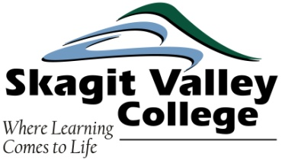

* Get Permission from your Faculty Chair or Sponsor.
* Determine the number of credits you need to earn for the quarter.
* Register for the appropriate class.
* Find a suitable paid or unpaid internship placement on or off campus.
* Complete a Cooperative Education Orientation session (live or online).
* Complete and turn in a Learning Contract (must be signed by relevant stakeholders).
* Create and submit all Learning Objectives for the quarter (must be signed by relevant stakeholders).
* Begin working for your Co-op Ed employer…do a good job and don’t forget to smile.
* Complete reflective writing components of the Co-op Ed experience.
* Complete and turn in all Co-op Ed assignments on time.

***“Tell me and I forget, teach me and I remember, involve me and I learn” –* Benjamin Franklin**